

COURSE NAME : Cyber Security and Digital Forensics
COURSE CODE : CSE2011
NAME : J.HARI KIRAN
REG.NO : 23BCE9689
SLOT : L33+L34
VENUE : 405-CB

Experiment – 2
Basic Host Discovery
nmap vtop.vitap.ac.in
→ Checks whether the target host is reachable and lists commonly open ports.
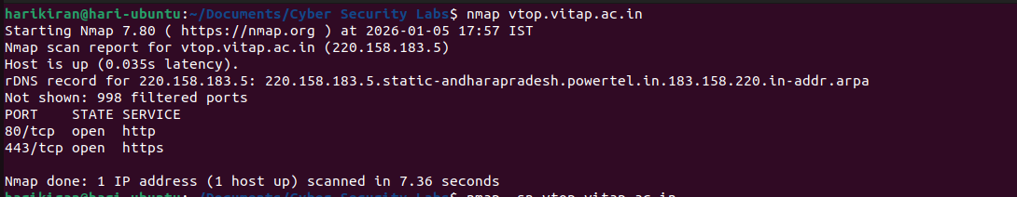

nmap -sn vtop.vitap.ac.in
→ Performs host discovery to check if the target is alive without port scanning.
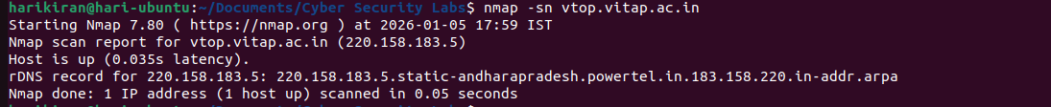

nmap -Pn vtop.vitap.ac.in
→ Scans the target without sending ping requests, useful when ICMP is blocked. 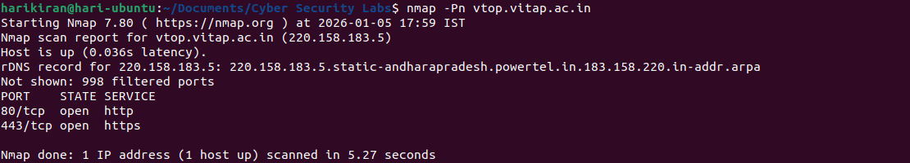

Port Scanning
nmap -p 80,443 vtop.vitap.ac.in
→ Scans only HTTP (80) and HTTPS (443) ports on the target server. 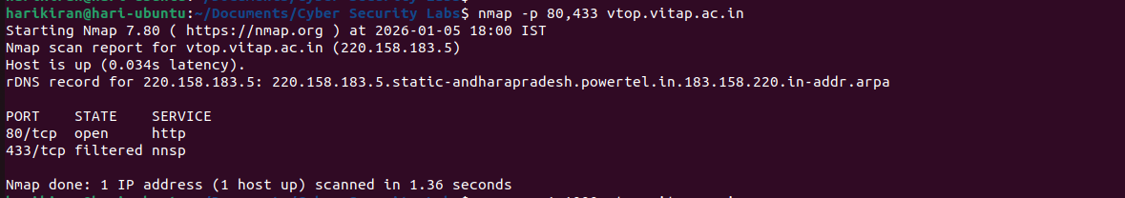

nmap -p 1-1000 vtop.vitap.ac.in
→ Scans ports from 1 to 1000 to identify commonly used services.
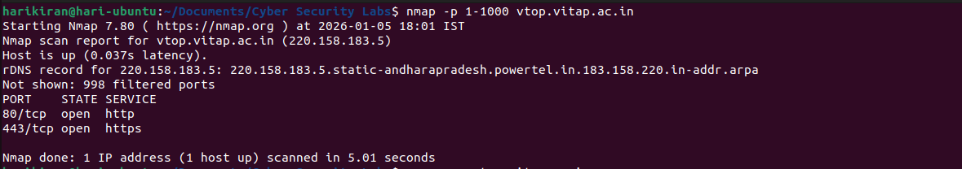

nmap -p- vtop.vitap.ac.in
→ Scans all 65,535 TCP ports on the target system.

TCP Scan Types
sudo nmap -sS vtop.vitap.ac.in
→ Performs a TCP SYN (stealth) scan to identify open ports.
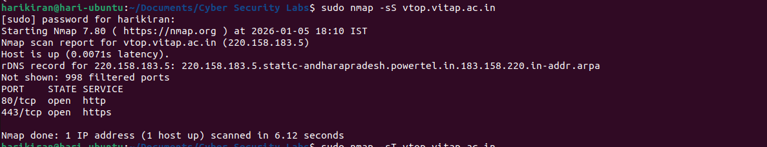

nmap -sT vtop.vitap.ac.in
→ Performs a TCP connect scan using the operating system’s networking stack.
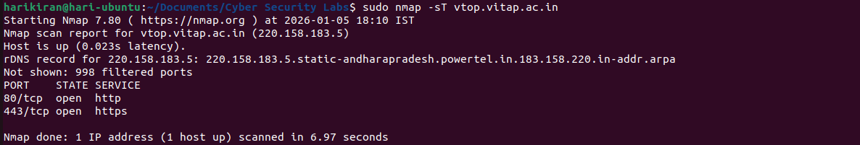

sudo nmap -sF vtop.vitap.ac.in
→ Performs a FIN scan to determine port states using FIN packets. 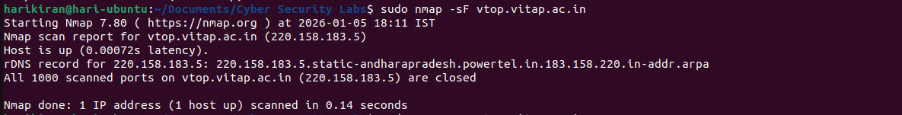

sudo nmap -sN vtop.vitap.ac.in
→ Performs a NULL scan by sending packets with no TCP flags set.
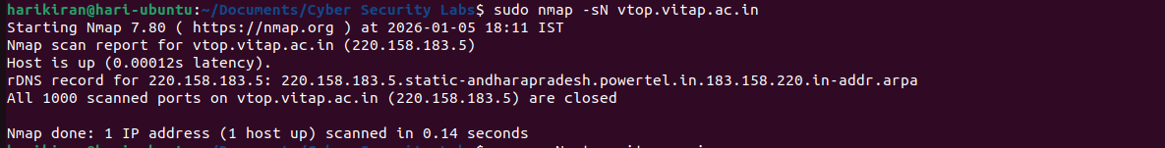

sudo nmap -sX vtop.vitap.ac.in
→ Performs an Xmas scan using FIN, PSH, and URG flags.
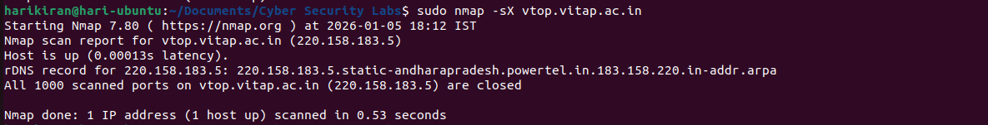

UDP Scanning
sudo nmap -sU vtop.vitap.ac.in
→ Scans UDP ports to identify UDP-based services. 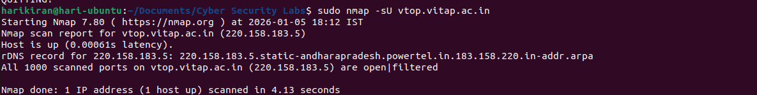

sudo nmap -sS -sU vtop.vitap.ac.in
→ Performs both TCP SYN and UDP scans together on the target.
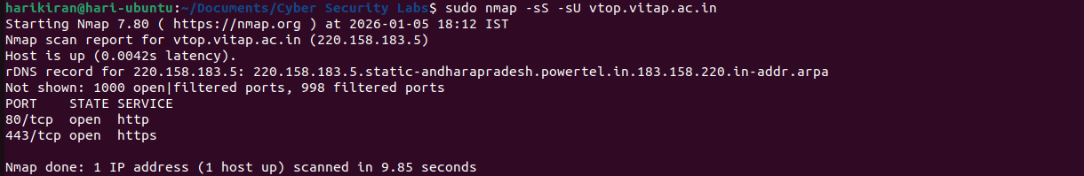

Service & OS Detection
nmap -sV vtop.vitap.ac.in
→ Detects service names and versions running on open ports.
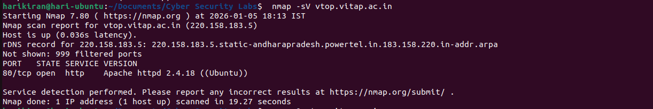

sudo nmap -O vtop.vitap.ac.in
→ Attempts to identify the operating system of the target host.
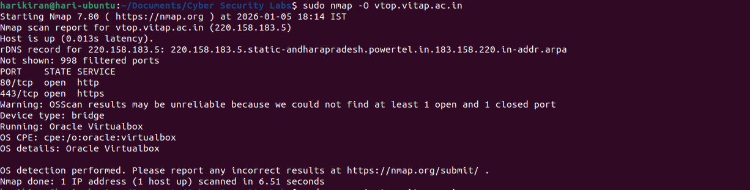

sudo nmap -A vtop.vitap.ac.in
→ Performs an aggressive scan including OS detection, service detection, scripts, and traceroute.
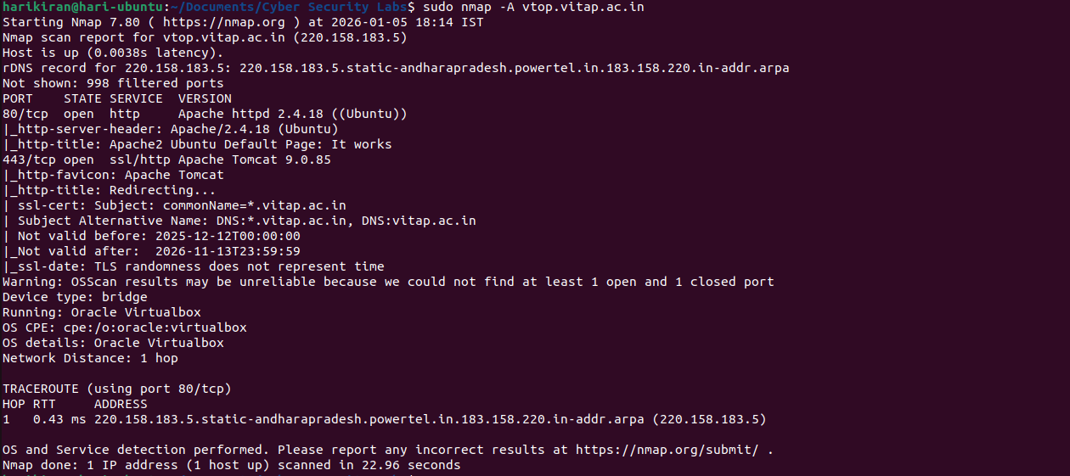

NSE (Nmap Scripting Engine) Scripts
nmap -sC vtop.vitap.ac.in
→ Runs default NSE scripts to gather additional information about services.
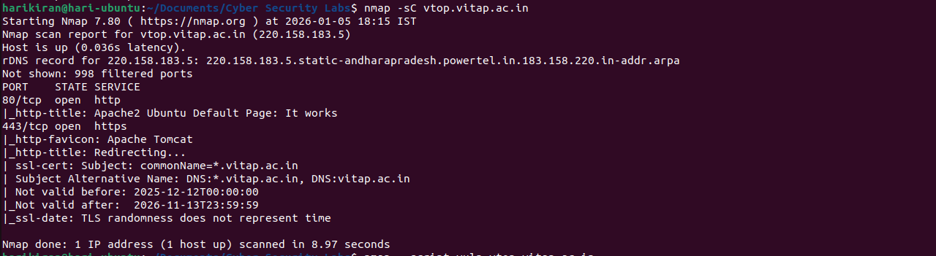
nmap --script vuln vtop.vitap.ac.in
→ Runs vulnerability detection scripts to check for known security issues.
nmap --script http-title vtop.vitap.ac.in
→ Retrieves the HTTP title of the web application running on the server. 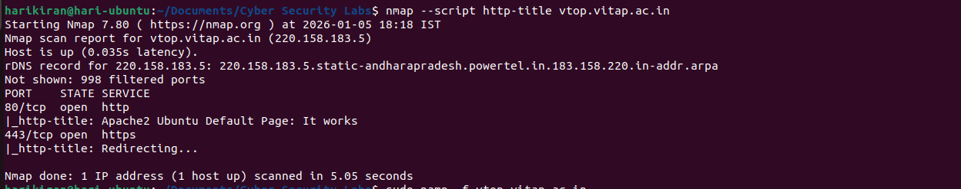

Firewall Evasion Techniques
sudo nmap -f vtop.vitap.ac.in
→ Uses fragmented packets to attempt bypassing firewall rules.
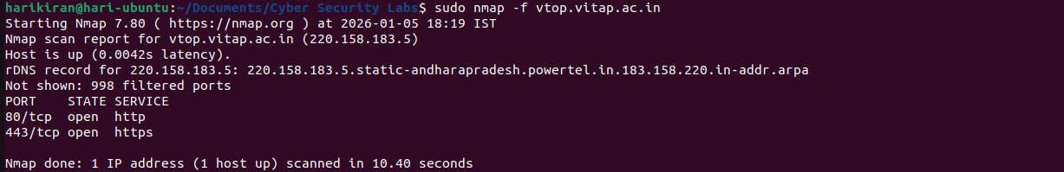

sudo nmap -D RND:10 vtop.vitap.ac.in
→ Uses decoy IP addresses to hide the real scanning source. 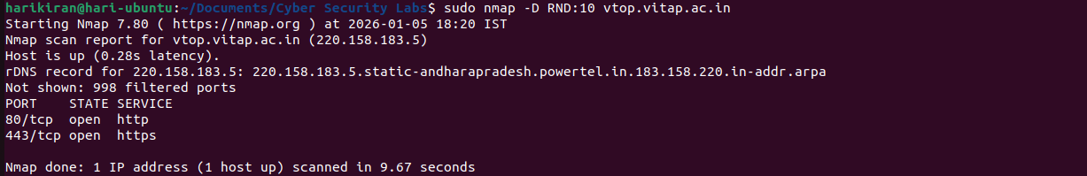

sudo nmap --source-port 53 vtop.vitap.ac.in
→ Uses source port 53 to attempt firewall evasion. 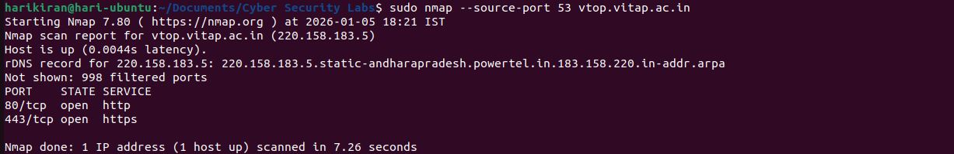

Timing & Output Options
nmap -T4 vtop.vitap.ac.in
→ Increases the scan speed using aggressive timing. 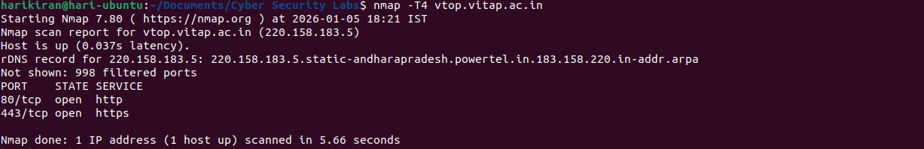

nmap -oN scan.txt vtop.vitap.ac.in
→ Saves the scan output in normal text format to a file.
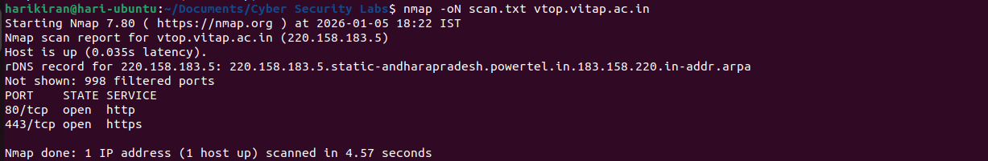

nmap -oA scan vtop.vitap.ac.in
→ Saves the scan output in all formats (normal, XML).

